ONLINE APPOINTMENT FOR HEALTHCARE CLINIC

Functional Requirements Document (FRD)

|  |  |  |  |
| --- | --- | --- | --- |
| Author | Version | Date | Description |
| Zohaib Waqar | 1.0 |  |  |

Table of Contents

**Introduction2**

Purpose4

Scope4

**Functional Requirements3**

**User Roles & Permissions3**

**UI Behavior & Validations4**

**Business Rules4**

**Non-Functional Requirements4**

**Assumptions & Dependencies5**

**Appendices5**

1. **Introduction**
   1. **Purpose**

This document defines the functional requirements for the Online Appointment Booking System for the Healthcare Clinic. It expands upon the high-level business requirements outlined in the BRD.

* 1. **Scope**

This system will allow patients to book, reschedule, and cancel appointments online. It includes role-based access for patients, doctors, and clinic admins. Reporting and notification features are also part of the scope.

1. **Functional Requirements**
   1. **Overview**

The Online Healthcare Appointment Booking System will deliver a range of features designed to enhance the patient experience and optimize the scheduling workflow for clinic staff and doctors. The following sections outline the detailed functionalities the system must support, as derived from the Business Requirements Document (BRD).

* 1. **Functional Requirements Table**

|  |  |  |  |
| --- | --- | --- | --- |
| ID | Description | Priority | Dependencies |
| FR-001 | Appointment Booking | Must Have | FR-005 |
| FR-002 | Rescheduling & Cancellation | Must Have | FR-001, FR-006 |
| FR-003 | Doctor Manual Override | Must Have | FR-006 |
| FR-004 | Appointment Reminders | Must Have | FR-001 |
| FR-005 | Real-time Doctor Availability | Must Have | Doctor Schedules |
| FR-006 | Role-Based Access | Must Have | User Management |
| FR-007 | Reporting & Analytics | Should Have | FR-001, FR-002 |
| FR-008 | Audit Logs | Must Have | FR-002, FR-003 |

Each requirement listed above is described in more detail in the subsections below.

* + 1. **FR-001 Appointment Booking**
       1. Patients can book appointments via a web interface.
       2. Only available time slots are shown based on doctor availability.
       3. Overlapping or duplicate appointments are not allowed.
       4. Confirmation via SMS/email is sent after booking.
    2. **FR-002 Rescheduling & Cancellation**
       1. Patients can reschedule or cancel their appointments.
       2. Rescheduling is allowed only if done at least 24 hours in advance.
       3. System logs all changes with timestamps.
    3. **FR-003 Doctor Manual Override**
       1. Doctors can manually adjust their schedules.
       2. Overrides are logged in the audit trail.
    4. **FR-004 Appointment Reminders**
       1. SMS and email reminders are sent 24 hours and 1 hour before the appointment.
       2. Configurable based on user preference.
    5. **FR-005 Real-time Doctor Availability**
       1. The system shows available time slots based on doctor's working hours and existing bookings.
    6. **FR-006 Role-Based Access**
       1. **Admin:** Full access to scheduling, reporting, and system settings.
       2. **Doctor:** View/edit personal schedule, view patient appointments.
       3. **Patient:** Book/reschedule/cancel own appointments.
    7. **FR-007 Reporting & Analytics**
       1. Daily/weekly appointments report.
       2. No-show rates report.
       3. Peak booking hours report.
    8. **FR-008 Audit Logs**
       1. Every change to appointment status, user role updates, and manual overrides is logged with user, timestamp, and action.

1. **User Roles & Permissions**

|  |  |
| --- | --- |
| Role | Access Rights |
| Admin | Full system control, reporting, user management |
| Doctor | Manage schedule, view appointments |
| Finance | Finance reports |
| Staff | Create schedule, appointment reports |
| Patient | Book/manage own appointments |

1. **UI Behavior & Validations**

|  |  |  |  |
| --- | --- | --- | --- |
|  | Field | Type | Validations |
| Register Page | | | |
| 1 | Govt ID | Mandatory | Must be alphanumeric, min 6–20 characters. No special characters allowed |
| 2 | Phone Number | Mandatory | Must be a 10-digit numeric value. |
| 3 | Password | Mandatory | Minimum 8 characters, must include 1 uppercase, 1 lowercase, 1 digit, and 1 special character |
| 4 | Confirm Password | Mandatory | Must match the Password field |
| Login Page | | | |
| 1 | User Name | Mandatory | Must match format used during registration |
| 2 | Password | Mandatory | Must match the one registered |
| Profile Page | | | |
| 1 | First Name | Mandatory | Only letters, 2–30 characters |
| 2 | Last Name | Mandatory | Only letters, 2–30 characters |
| 3 | Phone Number | Mandatory | 10-digit numeric value |
| 4 | Govt ID | Read Only | - |
| 5 | Existing Password | Mandatory | Must match current password in system |
| 6 | New Password | Optional | Minimum 8 characters, must include 1 uppercase, 1 lowercase, 1 digit, and 1 special character |
| 7 | Confirm Password | Optional | Must match the Password field |
| Manage User | | | |
| 1 | First Name | Mandatory | Only letters, 2–30 characters |
| 2 | Last Name | Mandatory | Only letters, 2–30 characters |
| 3 | Phone Number | Mandatory | 10-digit numeric value |
| 4 | Experience | Mandatory | Only positive whole numbers (0–50) |
| 5 | Qualification | Mandatory | Dropdown (Must select from predefined options) |
| 6 | Employment Type | Mandatory | Dropdown (Must select from predefined options) |
| Schedule Availability | | | |
| 1 | Year Control | Mandatory | Must be a valid year (e.g., current year or future years) |
| 2 | Scheduler Control | Mandatory | Only current or future dates are selectable  Past dates are disabled (grayed out and non-clickable)  Dates should belong to the selected year |
| Create Schedule | | | |
| 1 | Doctor Selection | Mandatory | Displays all available doctors as selectable cards with picture, name, and specialization  Only one doctor can be selected at a time. |
| 2 | Date Control | Mandatory | Allows selection of a date from the calendar  Past dates are **disabled** (cannot be selected) |
| 3 | Grid Layout | Mandatory | Rooms × Time Slots  Room Numbers (101 to 105)  Time slots from 09:00 to 18:00, in 30-minute intervals  **Break Time (13:00–13:30)** is greyed out and **disabled** (unavailable for scheduling) |
| Appointment Booking | | | |
| 1 | Patient Name | Mandatory | Only letters, 2–30 characters  Prefilled if user has profile and logged in |
| 2 | Contact | Mandatory | 10-digit numeric value  Prefilled if user has profile and logged in |
| 3 | Calendar | Mandatory | Only current and future dates are selectable Past dates are **disabled**  On selecting a date, the system fetches and displays **available time slots** for that date from the existing schedule |
| 4 | Time Slot Selector | Mandatory | Loads time slots based on selected date and pre-created schedule  Time slots already booked or outside of schedule are **disabled** and non-selectable  Users can only select **one** time slot  Upon selection, **available doctors** for that slot are fetched and displayed |
| 5 | Doctor Cards | Mandatory | Displays doctors who are available for the selected time slot  Only one doctor can be selected  If no doctors are available, display a message |
|  |  |  |  |
|  |  |  |  |
|  |  |  |  |

1. **Business Rules**
   1. Patients cannot book overlapping appointments.
   2. Rescheduling must be done 24+ hours in advance.
   3. Admins manage waitlists and urgent requests.
   4. All schedule changes are logged.
2. **Non-Functional Requirements**
   1. System uptime: 99%.
   2. Average response time < 2 seconds.
   3. Mobile responsive UI.
   4. Encrypted data in transit and at rest (HTTPS, HIPAA compliance if applicable).
3. **Assumptions & Dependencies**
   1. Doctors update their availability regularly.
   2. Internet access is available for patients to use the system.
   3. Notifications are handled via integrated SMS/email service.
4. **Appendices**

**Appendix ‘A’**

**Register**

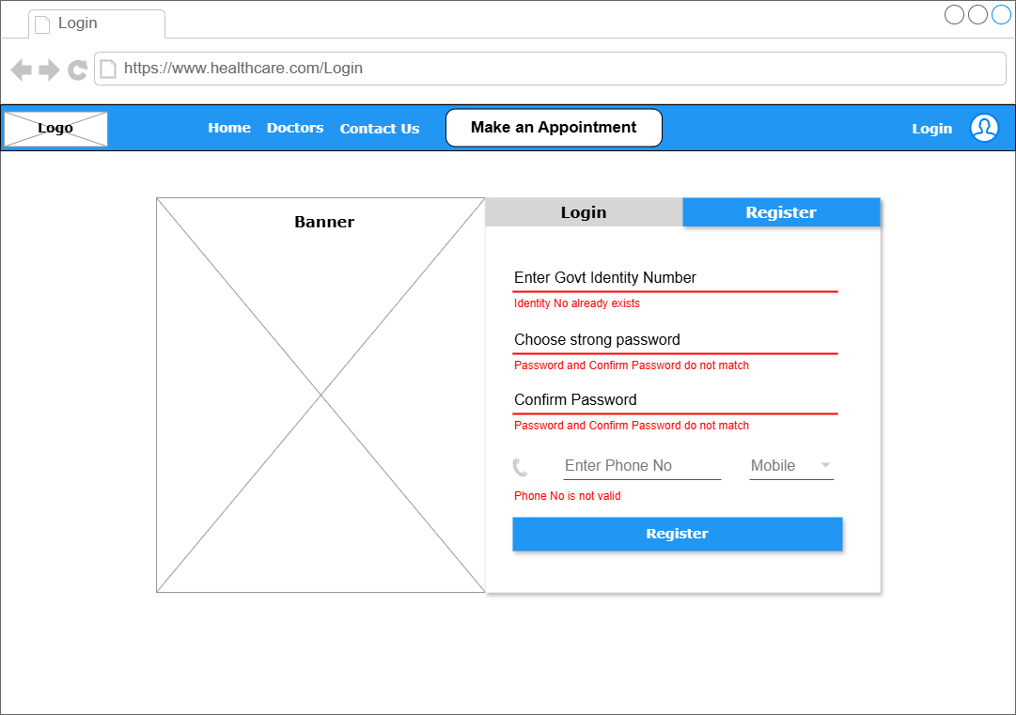

*Figure F1: User Registration with Validation*

**Appendix ‘B’**

**Login**

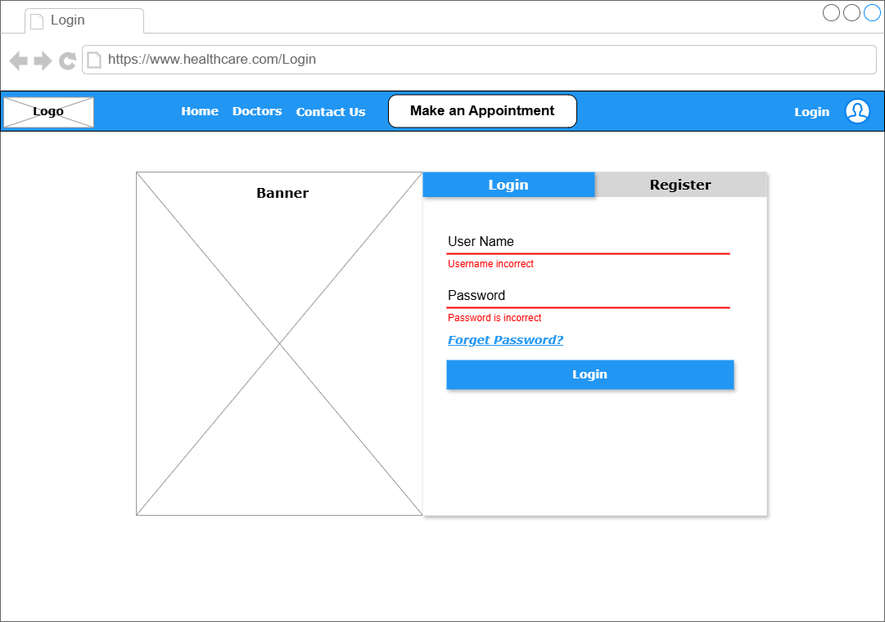

*Figure F2: User Login with Validation*

**Appendix ‘C’**

**User Profile**

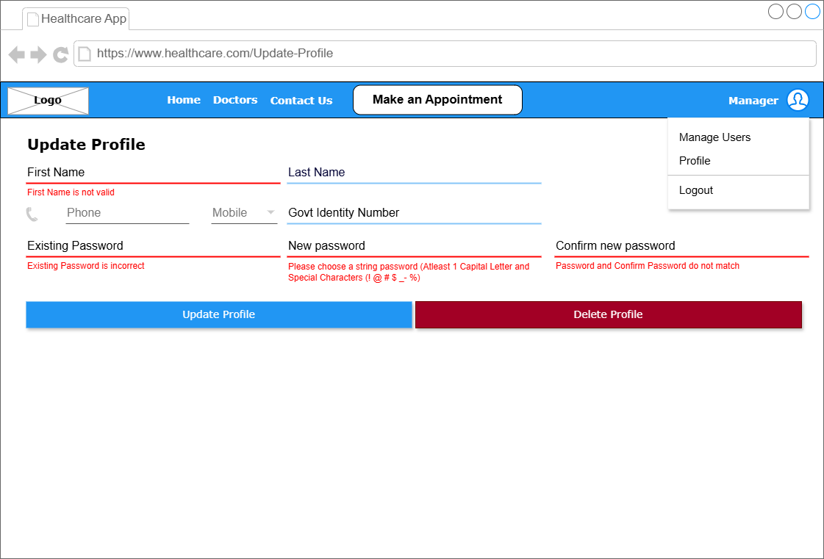

*Figure F3: User Profile with validation*

**Appendix ‘D’**

**Manage User**

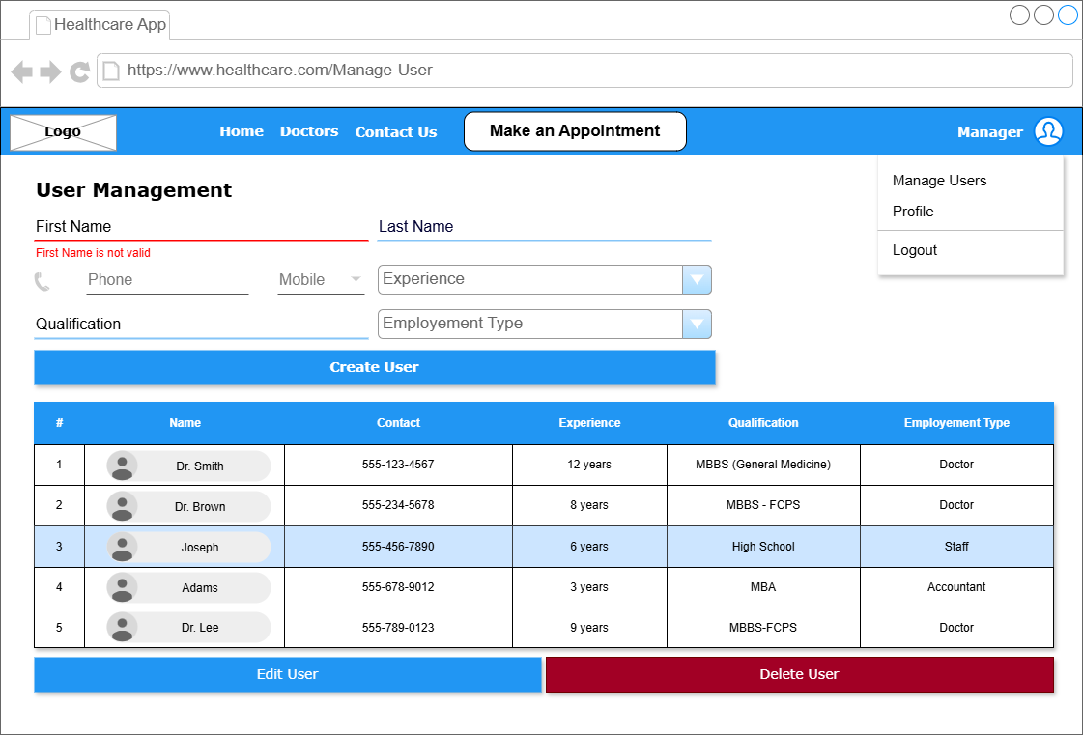

*Figure F4: User Management with Validation*

**Appendix ‘E’**

**Schedule Availability**

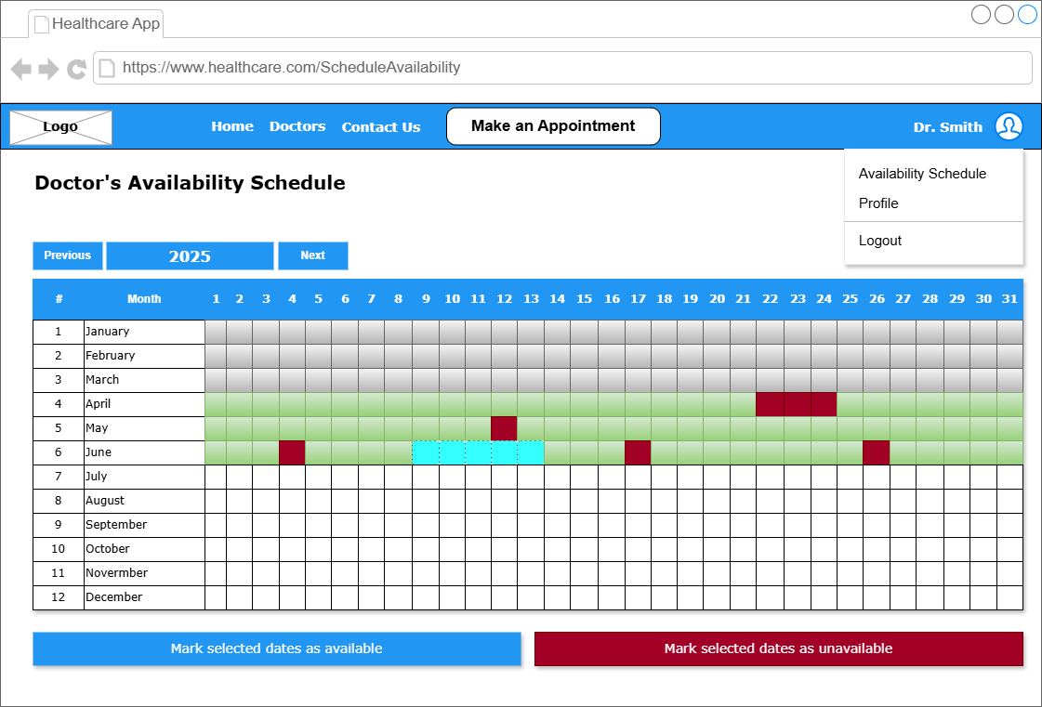

*Figure F5: Doctor’s Availability Schedule with disable fields for expired dates*

**Appendix ‘F’**

**Create Schedule**

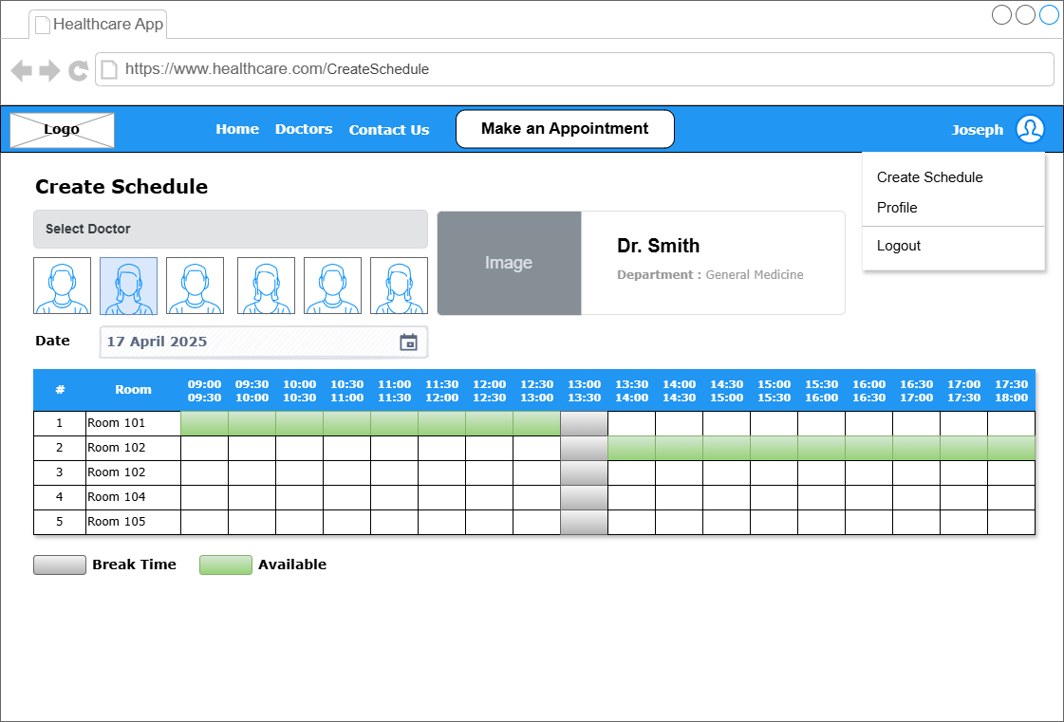

*Figure F6: Create Room & Time Wise Doctors Schedule*

**Appendix ‘G’**

**Appointment Booking**

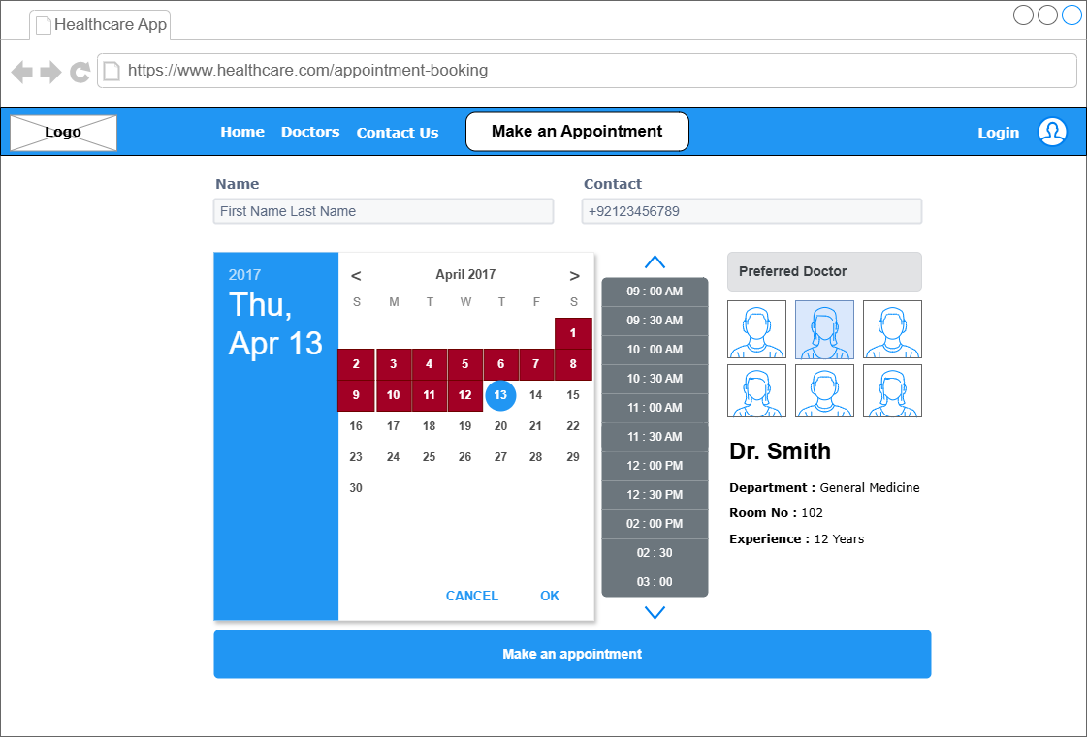

*Figure F7: Appointment Booking with disable fields*

**Appendix ‘H’**

**Appointment History**

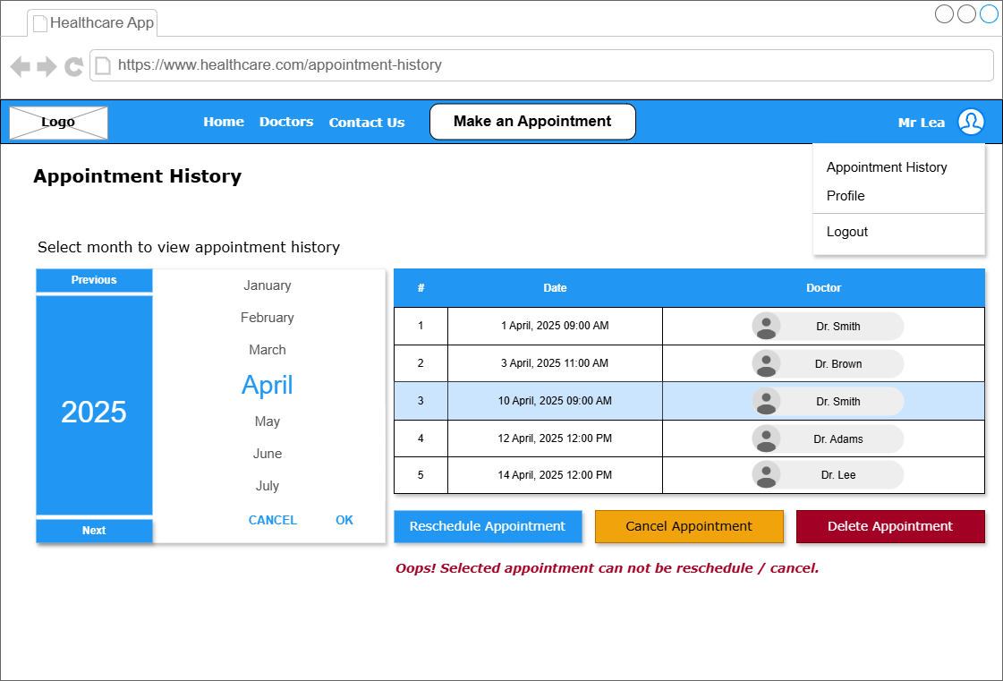

*Figure F8: Appointment History along with Reschedule and Cancel Validation*

**Appendix ‘I’**

**Report & Analytics**

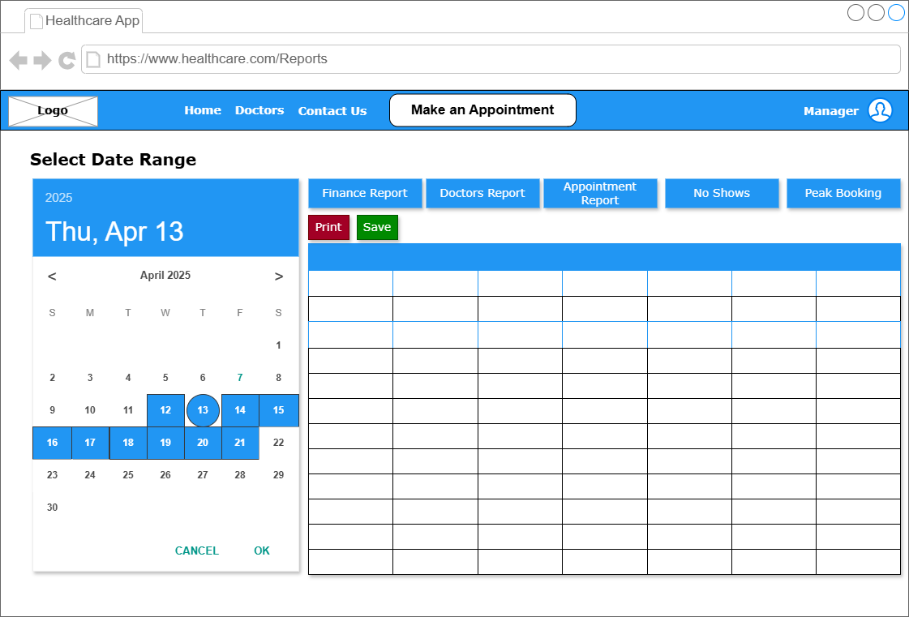

*Figure F9: Reports and Analytics for Manager with dates selection*